**Backing up (archiving) course.**

Courses may be made copied for archiving by using the [Course backup](https://docs.moodle.org/37/en/Course_backup) feature and including user details (assignment submissions, forum posts etc) (Note that this would be done by the administrator, as a regular course teacher is not allowed, for security reasons, to back up courses with user details.) The courses can then be stored either externally on a disc or within Moodle in a category named, for instance, "Archives" which can be hidden from regular users. The original course may then be "reset" for a new intake of students.

**Pros:**

* Students and teachers have live access to the prior instance of the module.
* The initial content and activities are already built for the incoming class
* The effort can be outsourced from central administration to each teacher if they have sufficient permissions in their own category

**Cons:**

* There is more than one copy of the course in the Moodle site
* If carried out by a teacher they now need course creation rights in a category.
* This is effort that is needed for every course and is a linear cost in time based on the number of courses that need resetting.

An alternative is to create empty courses for teachers, give them editing rights in the course and allow them to import the resources and activities from their old course into the new course. See [Import course data](https://docs.moodle.org/37/en/Import_course_data).

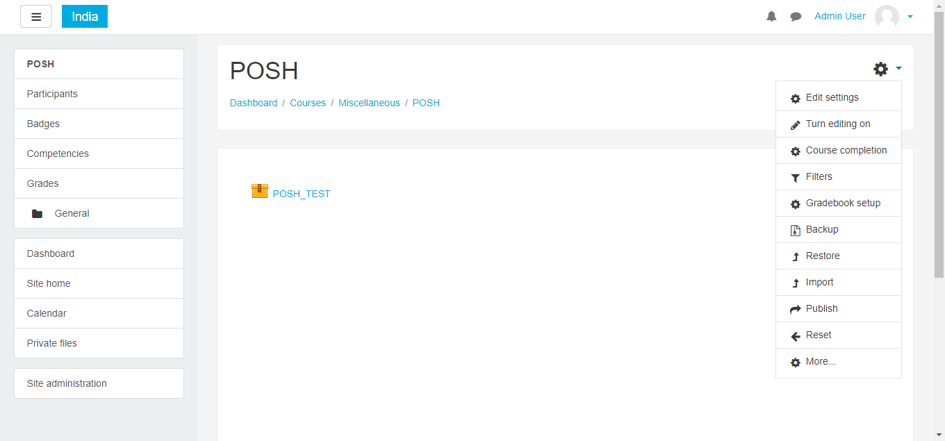

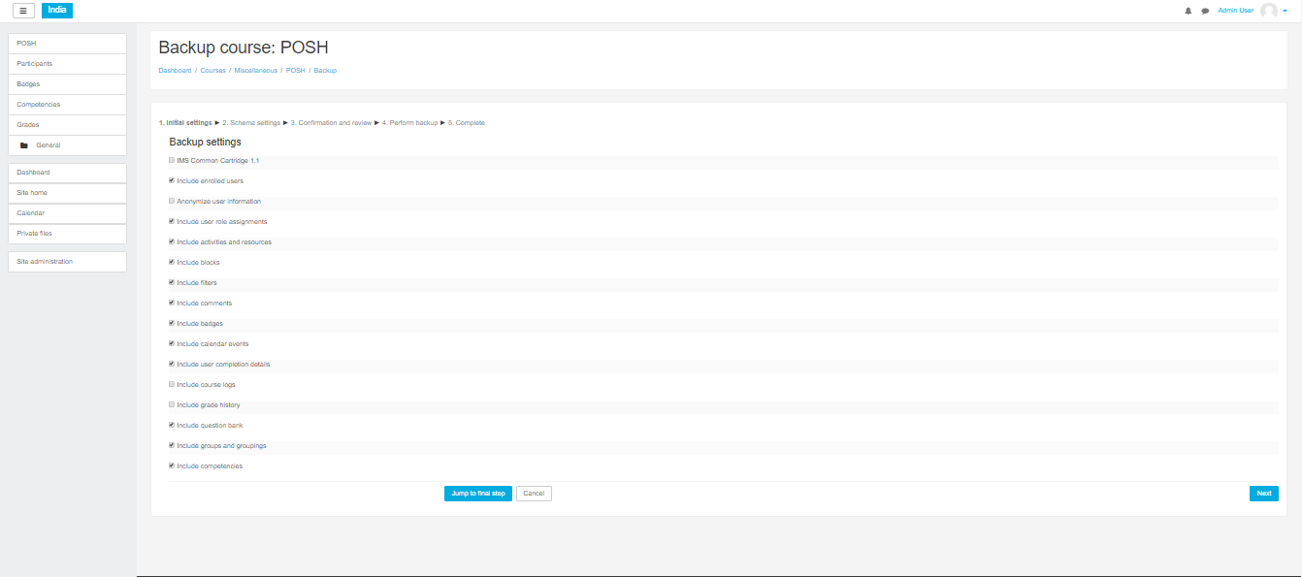

Select what fields you want then press next

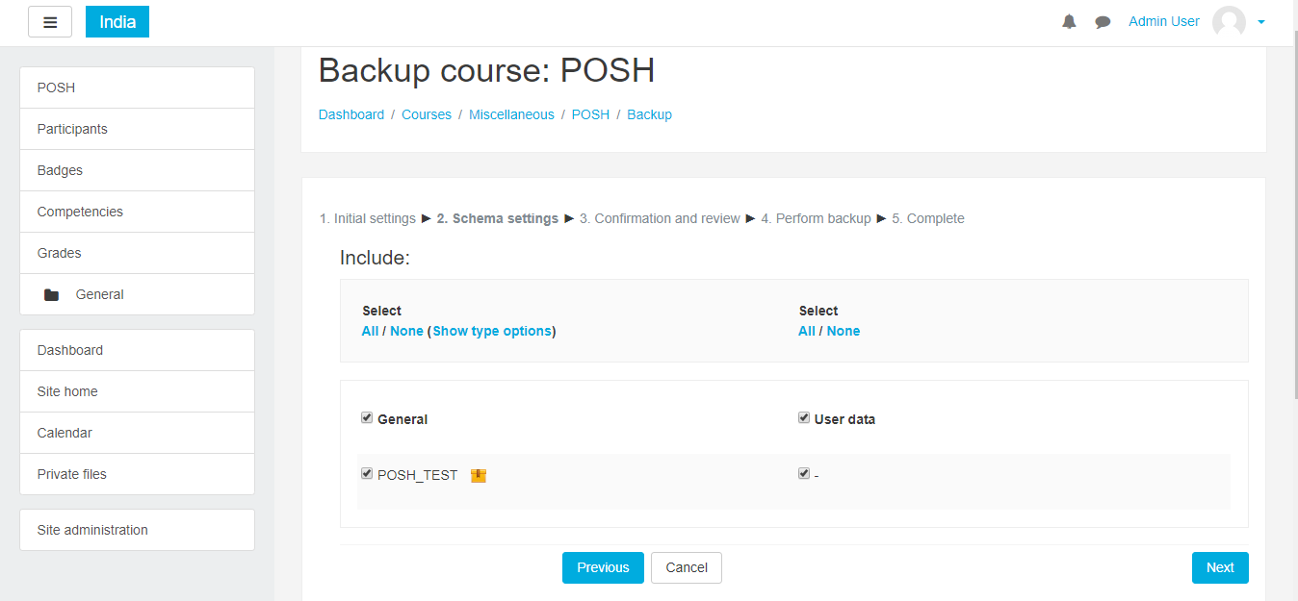

Check the selected fields are correct or not then next

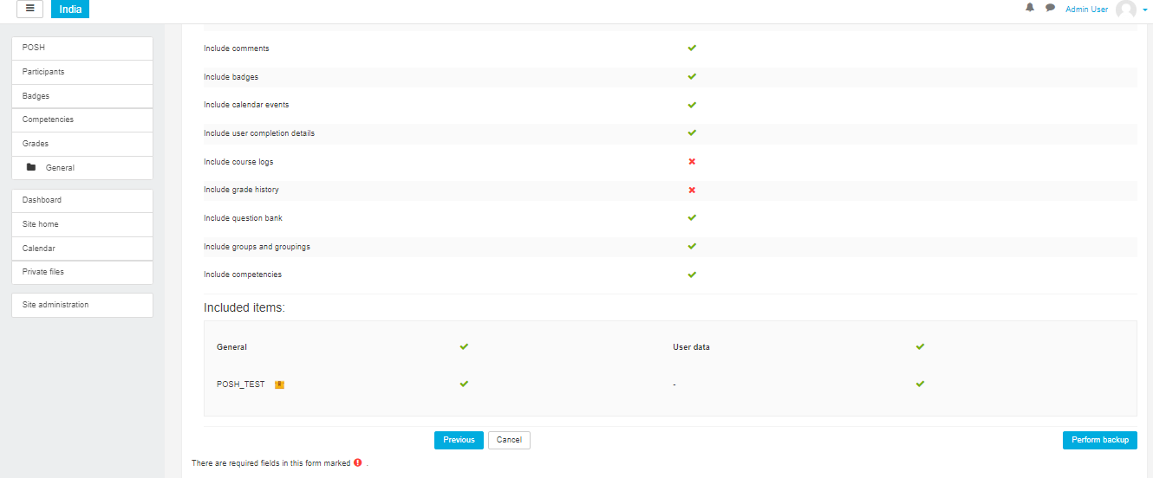

The backup file create automatically

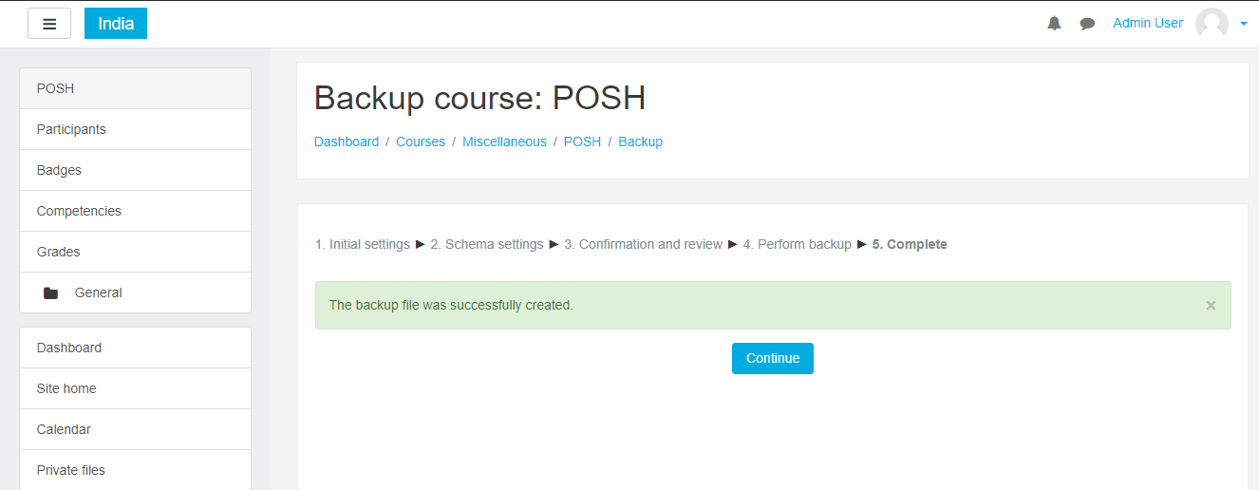

press continue

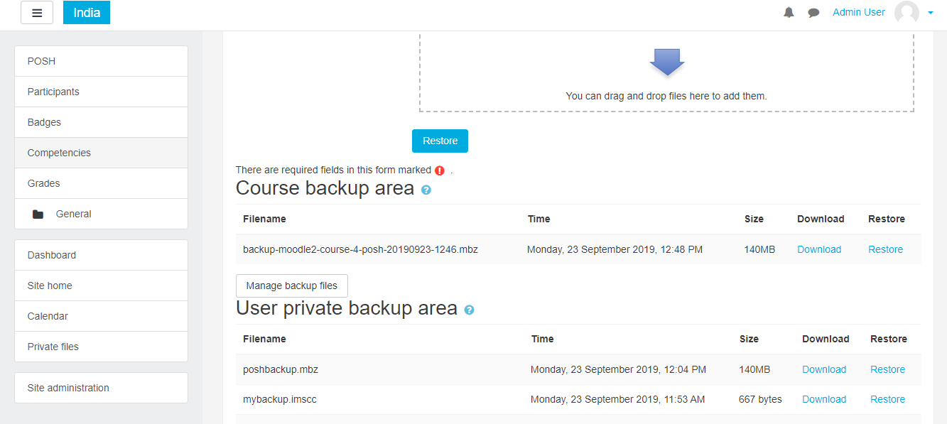

Download then if you want Reastore this file